Assignment - Hands on MCT

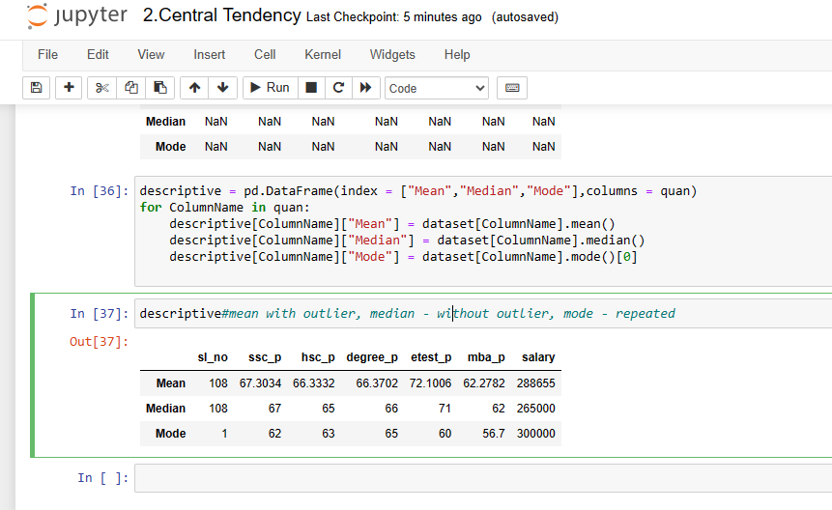

* The students belongs to this class are average perfomers.
* Average salary of each student is 300000 range.
* From sslc to degree they got average range marks and in enterance test alone they got 72 percent average.
* So, I found outlier in median of salary path as 265000 and repeated(majority) salary got by student is 300000.